INFORMATION TECHNOLOGY
GRADE 10 : CAPS
June 2013
PAPER 02
MEMORANDUM

Question 1: (10)

1.1 B
1.2 C
1.3 D
1.4 A
1.5 A
1.6 B
1.7 B
1.8 D
1.9 C
1.10 C (10)

Question 2: (10)

2.1 D
2.2 C
2.3 I
2.4 H
2.5 K
2.6 J
2.7 E
2.8 G
2.9 F
2.10 B (10)

Question 3: (10)

3.1 True 
3.2 True 
3.3 False  Plug n Play refers to new hardware being added without the need 2 load drivers.
3.4 True 
3.5 False  A computer worm can distribute itself on a harddrive AND over a network.

Question 4: (10)

4.1 EULA 
4.2 Algorithm 
4.3 Open Source Software 
4.4 ROM 
4.5 Spyware 

Question 5
5.1
5.1.1
5.1.1.1 Liquid Crystal Display 
5.1.1.2 Cathode Ray Tube 

5.1.2 Looks better. Produces less heat. Better picture Quality. Ergonomically better.
(any reasonable answer) 
5.2 Computer A : MS Windows XP Home 

5.3 Computer B. Having more RAM speeds up the system performance. Faster. 

5.4 RAM – Temporary memory used to store data that is currently been used.
Volatile memory – requires power to retain its data.
Needs to be refreshed.

RAM is Random Access Memory and refers to high speed
temporary memory  used to store data and programs while they are being processed.
ROM – Permanent memory used to store information about the Computer
system.
This memory retains its data when the Computer is off, data cannot be
changed.
ROM is Read Only Memory and refers to permanent memory which
contains the boot up instructions to load the operating system.
(any reasonable answer)

5.5 A device used to convert analogue signals from the telephone line to digital signals to
the computer and vice versa. 
A hardware device that is required to connect to the internet,

5.6 An inkjet printer sprays liquid ink onto paper via jets.  A laser printer uses toner instead of ink. 

5.7 A standard optical mouse uses an LED light to track how a mouse moves while a track ball mouse is a mechanical mouse which uses the movement of a rolling ball to move the cursor on screen. 

5.8 The MS-Office 2007 is on a 1 month Trial, therefore in order to continue to use the software,
MegaAccounts must purchase the software. 
Or they can just purchase a licence key to continue to use the software. 

5.9
5.9.1 Ergonomics refers to the study and design of workplace for comfort and safety of people in work environment.
Studies of the human body to try to design products so they better fit the way that actually function.  (any 1)
5.9.2 Bluetooth keyboard is wireless and therefore takes away all the clutter and cords.
Makes the place look and feel neat.
Keyboard can be used from a distance away from the computer system. (any 1)

5.10
5.10.1 Name of processors 
5.10.2 Intel 
5.10.3 The i-core series. The latest is currently the i 7. 

5.11 Computer A :DVD/CD-writer combo drive
This drive can view DVD, CDs and write CD only. It cannot copy/write DVDs.

Computer B :DVD writer
This drive can view and copy/write both DVD and CDs. 

5.12 USB has become standard for connection of modern peripheral devices, hence all devices are USB compatible.
USB are now very versatile ports. 

Question 6:

6.1
6.1.1 Application Software
Software written to perform a particular task.
This software is not essential for the Computer to work.

Applications software consists of programs that are designed to perform a particular function and are written to run under the control of a specific OS. 

6.1.2 System Software
Software that is intended to control, support or operate the computer.
This type of software is essential for the Computer to work.

Systems software refers to the OS which is a package of all the programs needed for the efficient running of the computer system. 

6.2
6.2.1 MS Windows XP Home 
6.2.2 MS-Office 2003 

6.3
- The OS manages the computer’s resources, such as the RAM, the monitor, storage devices, the keyboard, mouse and printer. It controls all the activities taking place in the computer. 
- The OS provides a user interfaces for a person to control computer operations. 
- The OS loads and runs application programs. 

Provides an Interface - to allow user interaction with the PC using GUIs.
Process and task management - manages the CPU and which programs and tasks can use the CPU.
Memory Management - manage the RAM to control how programs use it.
Input/Output Management - manages IO PC devices and how programs use these IO devices.
Disk management - manage storage, how data is organised on the storage device and how
programs access these devices.
(any 3 reasonable answers)

6.4 Linux, Unix 

6.5 A driver is small purpose written code (program) that allow the OS to understand and use a hardware that the OS is not familiar with.
A driver is a program designed to control a piece of hardware and make it work with a specific OS. 

6.6 Plug and play is when the OS automatically detects and installs the driver when a new device is attached to the PC. Eg. Graphic cards
Hot swappable – devices can be connected or disconnected while the computer is still running eg inserting and removing Memory Sticks. 

Question 7:
7.1

I | Enter hoursworked, hourlyrate
P | Grosswage ← hoursworked * hourlyrate
P | If ( grosswage >= 1000)
P | tax ← 1000 * 0.12
P | else
P | 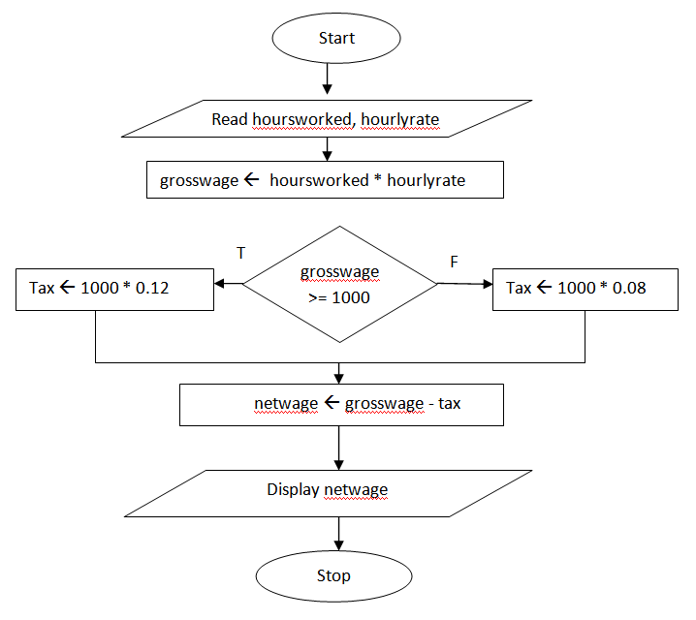  tax ←1000 * 0.08
P | netwage ← grosswage – tax
O | Display netwage

(1 mark for each box between start/stop boxes  + 1 mark for any algorithm attempt ) 8

7.2
7.2.1
4 3 9 8 13 3

6
Step No | Line No | counter | number | s | a | Output
1 | 1 / 2 |  |  | 0 | 0
2 | 3 | 1-5
3 | 5 / 6 |  | 4 | 4
4 | 5 / 6 |  | 3 | 7
5 | 5 / 6 |  | 9 | 16
6 | 5 / 6 |  | 8 | 24
7 | 5 / 6 |  | 13 | 37
8 | 8 |  |  |  | 7.4
9 | 9 |  |  |  |  | 37✓
10 | 10 |  |  |  |  | 7.4✓
 |  | ✓ | ✓ | ✓ | ✓
7.2.2 Determining and displaying the sum  and the average of 5 numbers 
entered by the user. 2[16]

Question 8

8.1 Data is raw unprocessed facts. Cannot make sense of these items. 
Information is processed data. Ordered list of items that has been sorted into categories 

8.2 Binary 
8.3
8.3.1 The binary number 110 1111₂ into decimal. 3
110 1111₂
= (1* 2⁰) + (1* 2¹) +(1* 2²) +(1* 2³) +(0* 2⁴) +(1* 2⁵) +(1* 2⁶) ✓
= 1 + 2 + 4 + 8 + 0 + 32 + 64 ✓
= 111₁₀ ✓

8.3.2 The decimal number 1466₁₀ into hexadecimal. 4
16 | 1466
16 | 91 | r 10 | A
16 | 5 | r 11 | B
 | 0 | r 5 | 5
 | ✓ | ✓
1466₁₀ = 5 B A ₁₆ ✓✓

Question 9

9.1
9.1.1 The body position – back and neck bending – chair height for arms and hands
Light use – not too dark, room well lit.
Eyesight – not too near the screen
RSI (any 3 reasonable answers)✓

9.1.2 Take regular breaks during which the user should get up from the computer.
Periodically look away from the screen, preferably at something in the distance so that the eyes can focus on distant objects.
Sit in a relaxed position preferably on a chair designed for use with computers
Use ergonomically designed hardware (any 2 reasonable answers)✓

9.2
9.2.1 Read and edit on screen before printing
Print on both sides of the paper

9.2.2 Recycle old computersby making use of companies that dispose of computers
Use energy compliant monitors
Use auto power shut down facilities

9.3 Refers to the society of “haves” and “have nots” as far as computers and the internet is concerned.  Refers to the people that have access to technology and those that don’t.

